**Data Visualization Project with the use of Tableau**

**The Nature and Impact of the Great Recession on the US Economy**

The great recession means that there was economic crisis in the world’s financial market and real estate. The great recession resulted to loss of jobs, loss of houses, loss of medical insurance, fall of GDP etc.

The major or popular great recession happened between December 2007 and June 2009. This was said to have occurred due to the Subprime Crisis i.e giving out mortgage loans to customers with a bad credit score and history.

The Troubled Asset Relief Program was introduced to quickly end the recession, thankfully the program worked.

The Visualization details below would show the impact and how the recession affected some part of the United States and the effect after June 2009.

Four Stages would be taken to achieve the aim of this project such as.

1. Data processing
2. Build your visualization
3. Build dashboards
4. Collecting dashboards into stories

**Stage 1: Data Processing**

**Data Sources:**

1. Rental Vacancy Rate Data: <https://geofred.stlouisfed.org/map/?th=rdpu&cc=9&rc=false&im=fractile&sb&lng=-89.56&lat=42.33&zm=4&sl&sv&am=Average&at=Not%20Seasonally%20Adjusted,%20Quarterly,%20End%20of%20Period,%20Number&sti=1100&fq=Quarterly&rt=state&un=lin&dt=2019-07-01>
2. Zillow Data (Serves as multiple sources): [https://www.zillow.com/research/data/](https://www.zillow.com/research/data/%20%20%20%20%20%20%20%20%20%20%20...S%20erves)
3. Home Ownership Data: <https://geofred.stlouisfed.org/map/?th=ylgnbu&cc=7&rc=false&im=fractile&sb&lng=-90&lat=40&zm=4&sl&sv&am=Average&at=Not%20Seasonally%20Adjusted,%20Annual,%20Percent&sti=2088&fq=Annual&rt=state&un=lin&dt=2018-01-01>
4. Resident Population: <https://geofred.stlouisfed.org/map/?th=ylgn&cc=5&rc=false&im=fractile&sb&lng=-90&lat=40&zm=4&sl&sv&am=Average&at=Not%20Seasonally%20Adjusted,%20Annual,%20Thousands%20of%20Persons&sti=1549&fq=Annual&rt=state&un=chg&dt=2019-01-01>
5. Rental Vacancy Rate: <https://geofred.stlouisfed.org/map/?th=reds&cc=8&rc=false&im=fractile&sb&lng=-90&lat=40&zm=4&sl&sv&am=Average&at=Not%20Seasonally%20Adjusted,%20Annual,%20Percent&sti=1863&fq=Annual&rt=state&un=lin&dt=2018-01-01>

The data was clean by filtering out the unused states and ensuring all the columns are well named and all aligned.

As suggested each question should be followed with a visualization.

General Questions to be asked of the data and can be answered with the visualization:

**Question 1/Visualization 1: Average Rental Vacancy**

1. What is the average rental vacancy in the four states across the years between 2002 and 2012?
2. What is the average rental vacancy prior to the recession and post-recession?
3. Does it mean an average resident in each state couldn’t afford to pay for apartment?

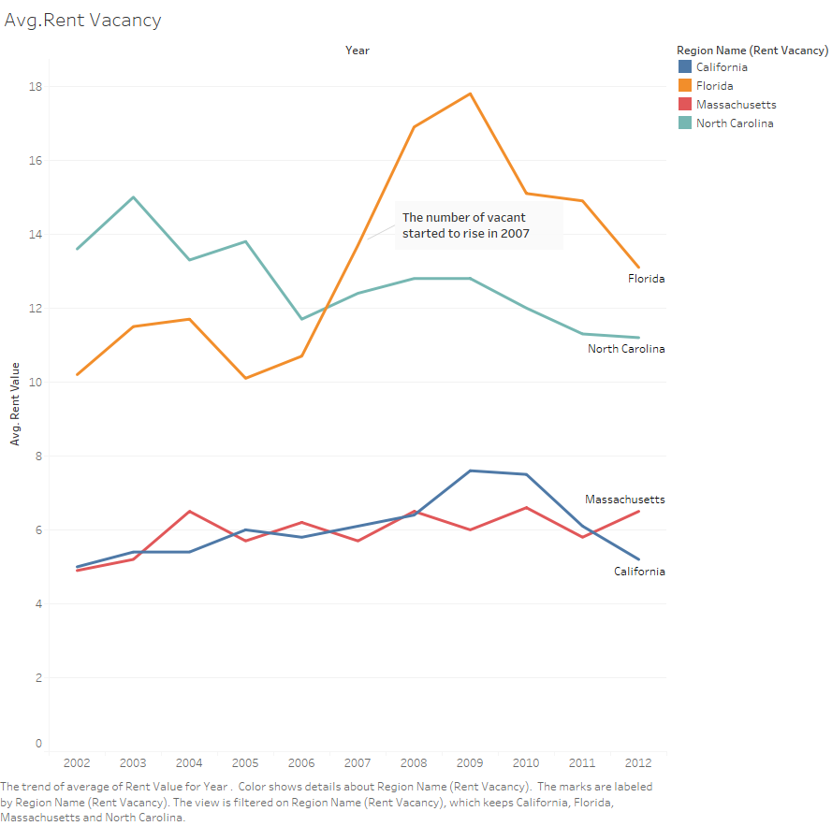

Apart from showing the states’ map in my dashboard, it would be clearer and more seen with a line graph what the average rental in the states are and the impact it has in general.

The increase in rent vacancy in Florida could be due to the recession as well as California. The two states rent vacancy was fluctuating before the rise in the recession.

It is seen that a lot of people vacate their houses reason could be their inability to pay for rent.

**Question 2/ Visualization 2: Average Population**

1. **What is the average number of residents and population in the four states?**
2. **Was there a reduction in the average population before the recession?**
3. **Was there an increment or reduction after the recession?**

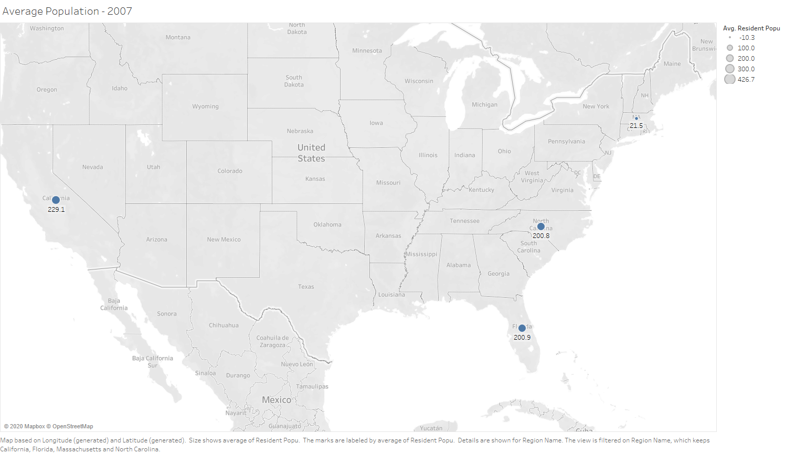

Though there is filter attached to the map above so as to check the trend of the average population between 2002 and 2020 and importantly between 2007 and 2009.

**Question 3/Visualization 3: Average Income**

1. What could have caused the trend in all states to go uploads during and after the recession?

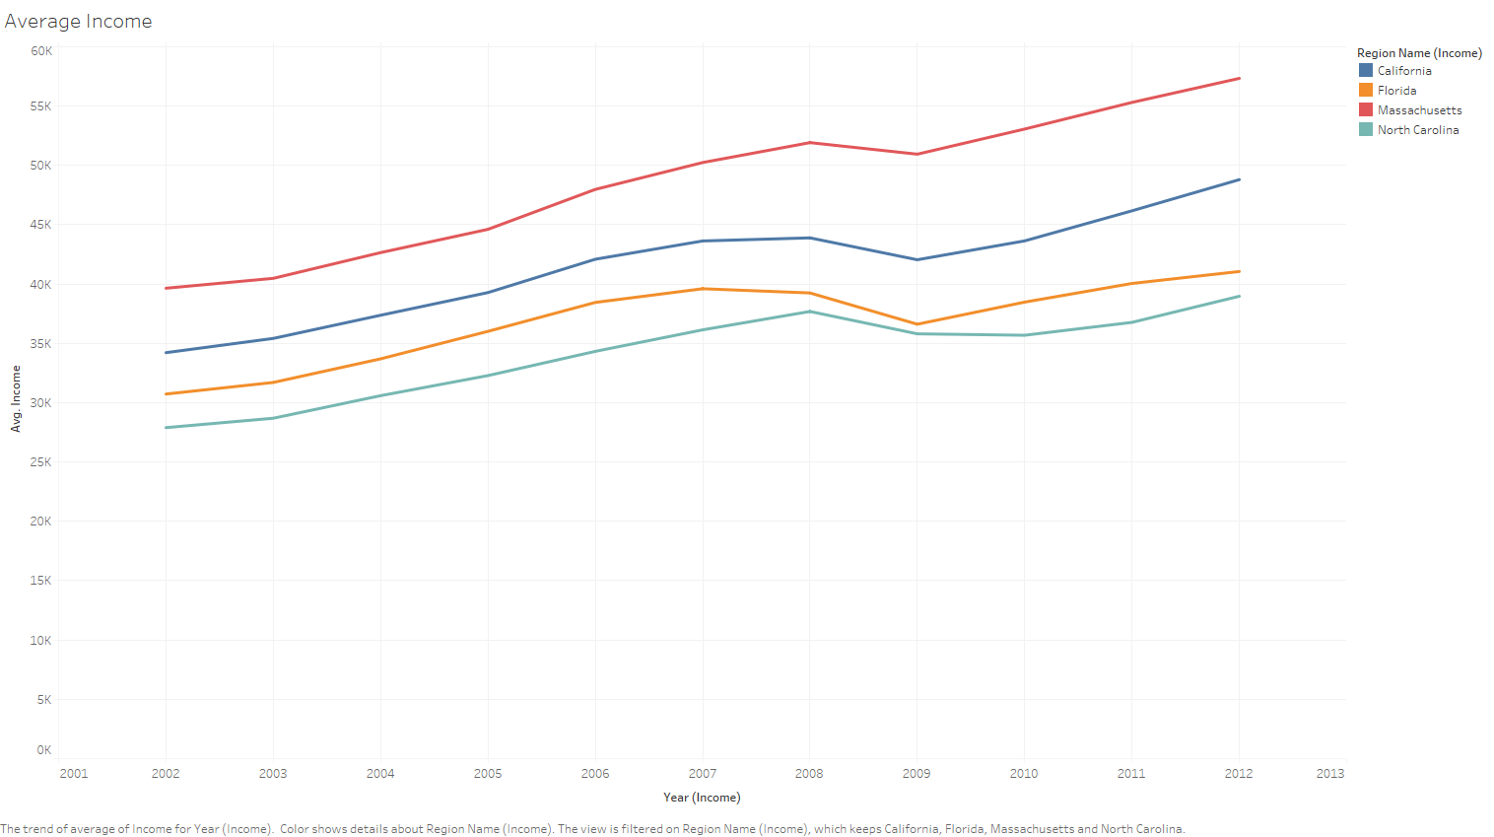

The incremental trend does not obviously show the impact of the recession on the average income of the residents in the four states except for a sharp curve in 2009.

**Question 3/ Visualization 3: House Price**

1. What is being understood by the with the trend? What is it with the slope?
2. Is there recession having an effect before 2007?
3. Can we say houses cost more in Massachusetts and California than North Carolina and Florida?

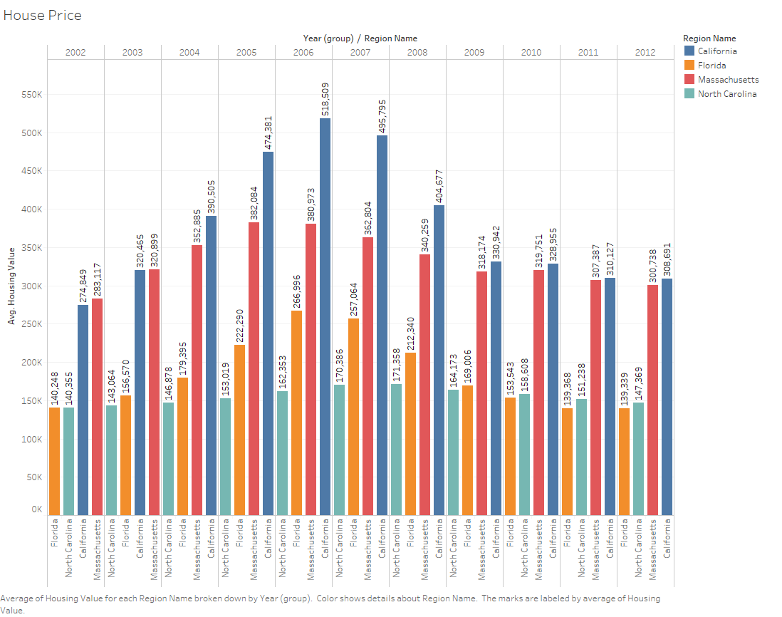

The housing price is becoming high between 2004 and 2009, which implies that the recession could have been slowly felt but cognizance was not taken until December 2017. The housing price is higher in Massachusetts and California than Florida and North Carolina.

**Question 4/ Visualization 4:**

1. Could we say if the house monthly sales in Massachusetts and California is quite more than that of North Carolina and Florida?
2. Can we affirm that the recession only majorly affects Massachusetts and California?

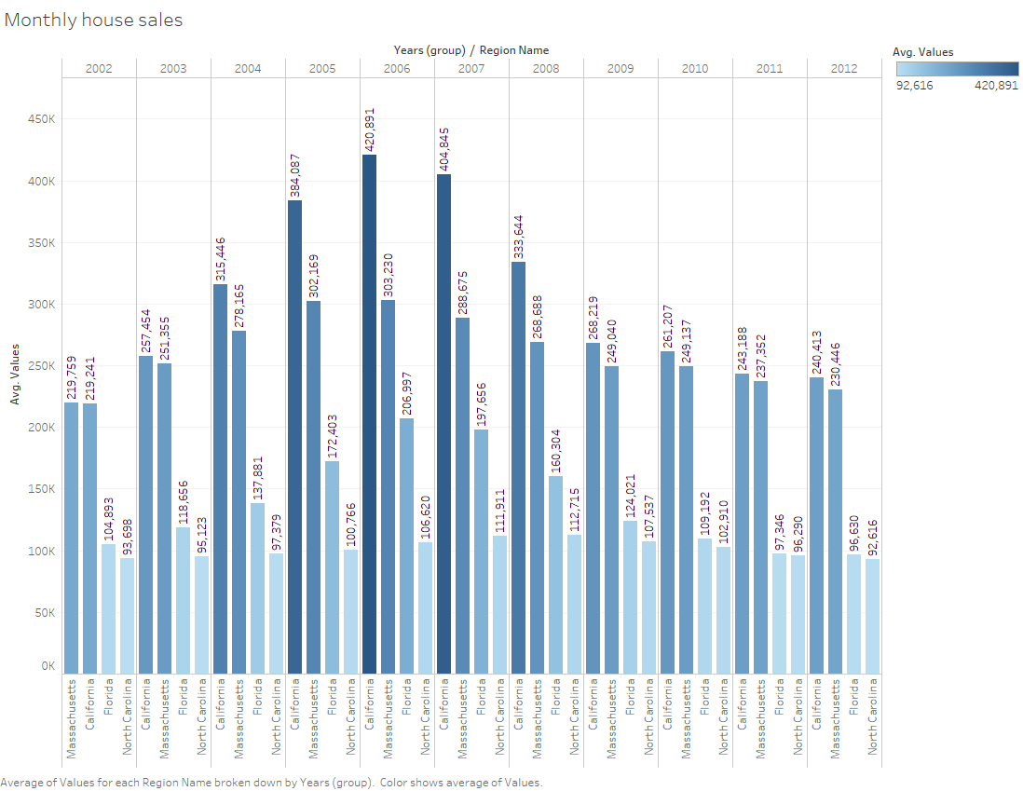

As seen, there was an increase in the sales of houses per month, meaning people might be losing their houses and putting up for sale except for North Carolina. The graph shows that housing price is generally low in North Carolina.

**Question 5/ Visualization 5:**

1. **What is the average value for 2-bedroom houses in the states across the years?**
2. **What could have made the 2-bedroom value drop in 2007?**

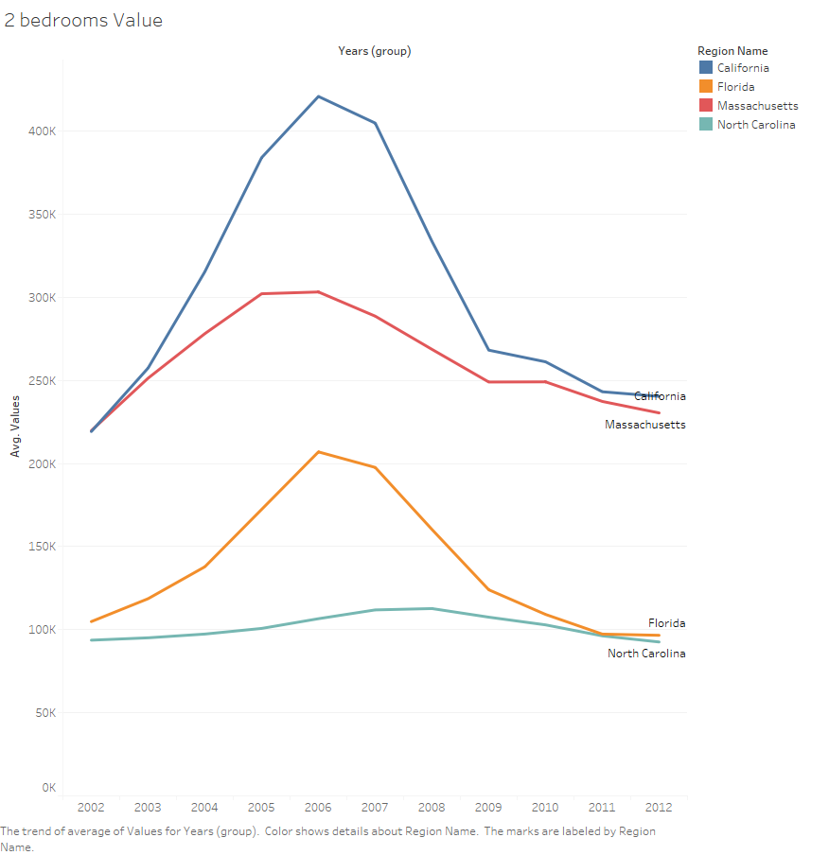

The recession maybe the cause of the rise in the average cost of two-bedroom house.

Dashboards and the Answers they convey

Housing Dashboard

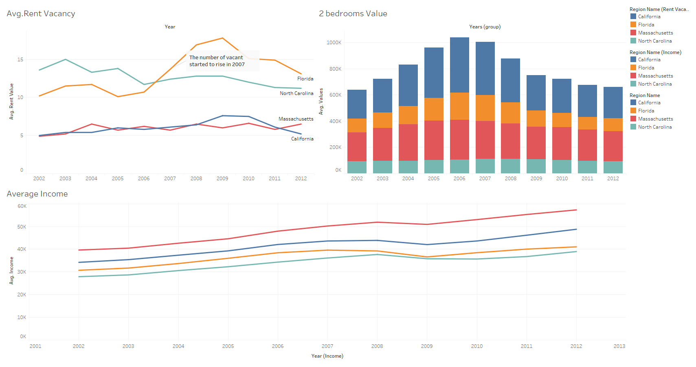

As we can see the audience could possibly deduce that the effect of the recession started at the end of 2006 and dip down in 2011, it reached the peak of average rent vacancy in 2009 before declining while the average rent vacancy in North Carolina, Massachusetts and California fluctuates and not as high as that of Florida.

There is a flow of trend with the average income across the years in the four states is linear and incremental except for the shape curve in year 2009.

Homeowner Dashboard

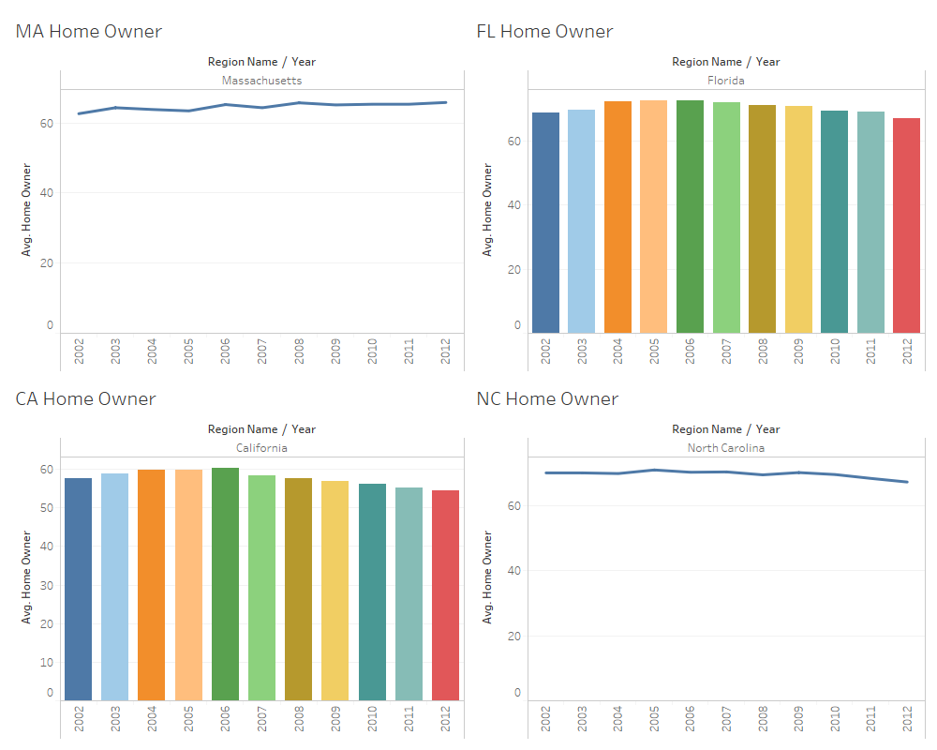

It is worthy to note that the home owner was stable until 2009 when there was a decline in home ownership in California, North Carolina and Florida with Massachusetts which has a roughly steady home owner after the recession.

Commercial Bank Dashboard

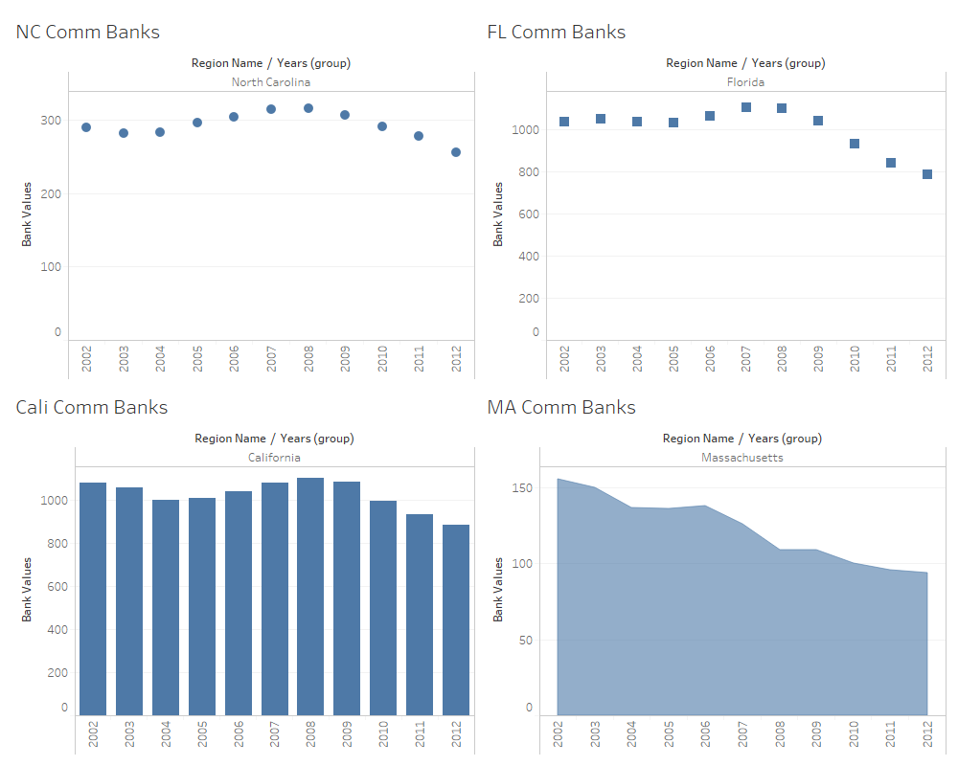

The commercial banks in North Carolina, Florida and California took a bell shape with rise before the start of the recession and decline after the recession.

House Sales Dashboard

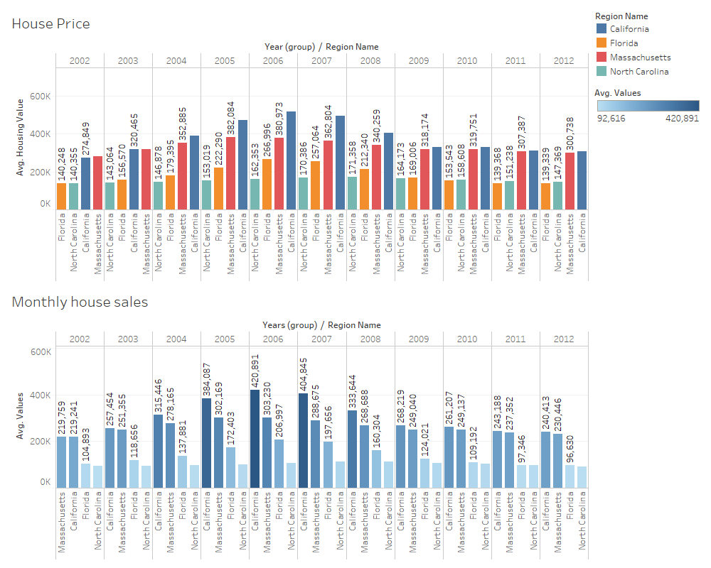

The average monthly sales and house price of houses in North Carolina has only a slight differences in its value but Massachusetts, Florida and California had a bell shape value that rises from year 2002 with peak value in year 2006 and year 20017.

Health Dashboard

Questions/Visualization: What disease is the main cause of death? Do people commit suicide? Are people depressed?

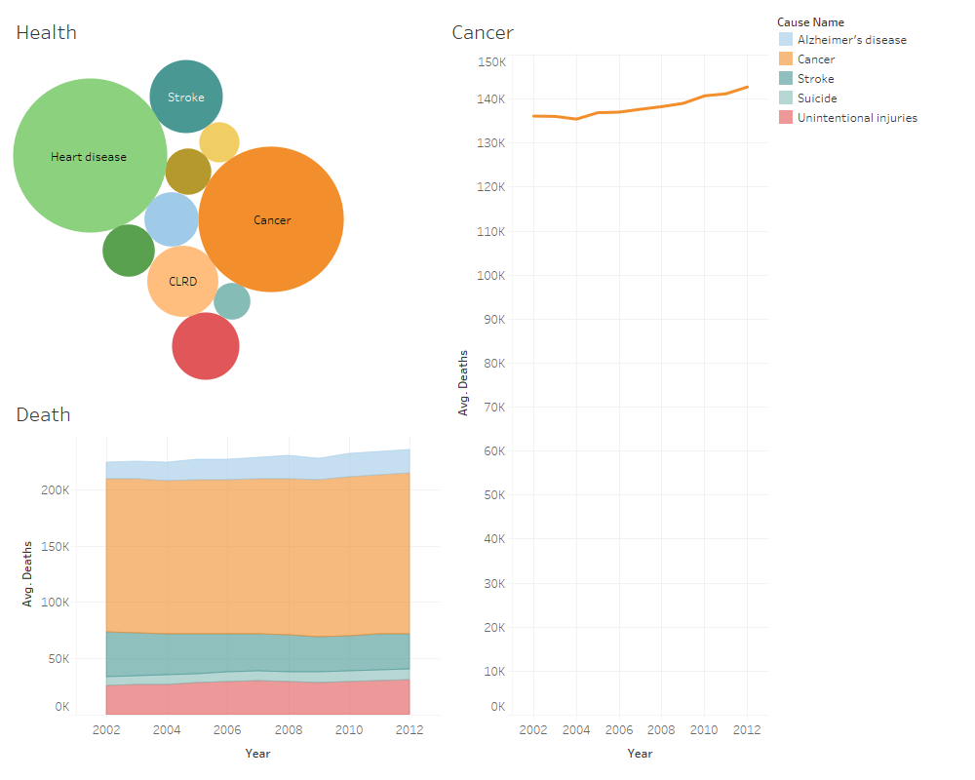

It can be seen that cancer being the cause of death is more than all other causes of death combined. Also, heart diseases are quite close to cancer in its impact to the society. Suicide slightly increased during the recession. The suicide could be due to depression.